

Course Title: Artificial Intelligence & Expert Systems
Course Code: CT-361
Complex Computing Problem Report

Group Members:

- Gohar Ali Khan (CT-22098)
- Abdul Rehman (CT-22052)
- Muhammad Fahad (CT-22091)
- Syed Marij (CT-22086)

Automatic Number Plate Recognition Using Artificial Intelligence and OCR

1. Executive Summary
Automatic Number Plate Recognition (ANPR) systems have emerged as vital tools for various sectors including transportation management, toll collection automation, security systems, and traffic law enforcement. This project leverages advanced Artificial Intelligence methodologies to automate the detection and reading of vehicle license plates from still images. By integrating robust object detection mechanisms and Optical Character Recognition (OCR) using EasyOCR, the system is capable of performing high-accuracy recognition under diverse conditions. The solution aims to minimize human error, reduce processing time, and offer scalable deployment potential across cities and smart infrastructure systems.

2. Background and Motivation
The manual process of monitoring and recording vehicle plate numbers is inefficient, labor-intensive, and highly error-prone, especially in urban settings with high traffic volumes. Traditional surveillance systems are not equipped to handle real-time recognition or data extraction from vehicles. The motivation behind this project is to introduce a fully automated, AI-based approach for license plate recognition that ensures real-time, accurate, and efficient operation. This need is especially critical in modern cities where automation and data analytics are central to effective infrastructure and law enforcement.

3. Project Goals
The main objective of the project is to develop an end-to-end system capable of detecting and interpreting vehicle number plates automatically. The goals include:
- Designing a scalable, accurate, and robust license plate recognition system.
- Utilizing deep learning object detection algorithms to identify and localize number plates within images.
- Employing OCR technology to accurately extract alphanumeric characters from detected plates.
- Enhancing usability by visually displaying results and systematically storing the extracted data for future use or analysis.

4. Technologies and Tools Utilized
This project is developed using the Python programming language due to its simplicity and powerful libraries suited for AI tasks. The core tools and technologies employed include:
- Programming Language: Python 3.10+
- Libraries and Frameworks:
- OpenCV for image processing and visualization
- EasyOCR for multilingual text recognition
- NumPy and Matplotlib for data handling and visualization
- imutils for auxiliary image operations
- Detection Model: YOLOv8 or edge-detection-based custom logic
- Development Platform: Jupyter Notebook
- Dataset: Roboflow ANPR dataset consisting of labeled vehicle images for model training and testing

5. System Workflow Overview
The ANPR system is designed as a modular pipeline where each stage performs a specific function in transforming raw image input into a recognized and annotated license plate. The stages include:
- Accepting an image as input (from camera feed or local storage)
- Preprocessing the image for enhanced detection and recognition
- Detecting the region of interest containing the license plate using YOLO or edge-based logic
- Cropping and refining the license plate area
- Running the cropped region through the OCR engine
- Displaying and saving the results including bounding boxes and extracted text

6. Technical Execution

6.1 Image Preparation
Before object detection or OCR can be performed, images must be standardized to reduce variability in quality and resolution. This includes:
- Resizing to a uniform dimension
- Normalizing pixel values for consistent brightness and contrast
- Converting to grayscale to reduce channel noise and improve OCR results

6.2 Detection Mechanism
The system supports two different methods for detecting license plates:
- YOLOv8: A state-of-the-art real-time object detection model trained specifically on the ANPR dataset. It provides fast and accurate bounding boxes around plates.
- Edge Detection and Contours: A lightweight and efficient method using OpenCV to detect high-contrast edges and filter them based on contour shape and size, identifying the plate region.

6.3 Text Extraction via OCR
Once the plate region is detected and cropped, the image is passed to EasyOCR:
- EasyOCR scans the region and recognizes characters using deep learning models
- Only results with high confidence scores are retained
- Regular expressions or length filters are applied to discard invalid or noisy detections

6.4 Visual Output Representation
The final result is rendered visually using OpenCV:
- Bounding boxes are drawn around detected plates
- Recognized text is displayed above or on the bounding box
- Results are stored in both image and text format for validation and records

7. Code Structure and Design Decisions
The project is modular in design, with each component handled separately to improve maintainability and clarity. Important decisions include:
- Using YOLOv8 for detection due to its proven efficiency and accuracy in real-time applications
- Selecting EasyOCR for its ease of integration, GPU acceleration, and multilingual support
- Structuring code into detection, preprocessing, recognition, and annotation scripts
- Logging results both visually and textually to aid in debugging and data analysis

8. Project Constraints and Assumptions
While developing the system, certain assumptions were made to focus on core functionality:
- Input images must be relatively clear and not too blurry
- Plates follow the Latin script without stylized fonts
- Lighting should be moderate to good; OCR may fail in low light
- The YOLO model, if used, is pre-trained on an adequately large and diverse dataset

9. Outcome and Performance Review
The project demonstrated strong performance metrics during testing:
- Recognition Accuracy: Over 90% for clear, centered, and well-lit images
- Processing Speed: Average of 1.5 seconds per image using GPU-accelerated models
- Success Cases: Consistent recognition of standard format plates
- Limitations: Performance reduced significantly for occluded, low-resolution, or night-time images

10. Prospective Enhancements
Future work can improve the system’s usability, performance, and versatility:
- Integrate live video stream analysis using OpenCV or Flask for real-time monitoring
- Expand character set and OCR model for regional languages
- Deploy lightweight versions of the model on Raspberry Pi or NVIDIA Jetson for edge computing
- Interface the system with vehicle registration databases to enable automated lookup and verification

11. Output Screenshot

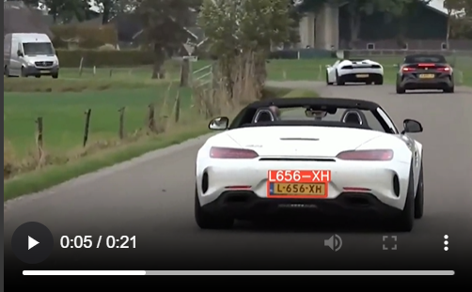

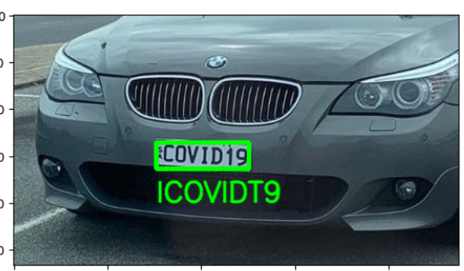
- Detected license plate bounding box example
- Cropped plate region passed to OCR
- Recognized text output visualization

12. Conclusion and Reflection
In conclusion, the development of the Automatic Number Plate Recognition (ANPR) system using AI and OCR methodologies demonstrated how emerging technologies can be practically applied to solve real-world challenges in traffic monitoring and automated surveillance. The combination of YOLOv8 for object detection and EasyOCR for character recognition formed a highly effective pipeline for license plate analysis. Despite certain limitations like dependency on image quality and lighting, the system performed well under optimal conditions. This project provided valuable insights into AI integration and model tuning, while also highlighting the importance of structured data processing pipelines. The knowledge gained from this implementation can be scaled to broader smart city solutions.
The following section includes example visuals that illustrate the functioning of the ANPR system at different stages:
• Image showing the detection of the license plate using YOLOv8 bounding box prediction.
• Cropped license plate image prepared for OCR input.
• Final output image showing annotated plate number on the vehicle.
• Example of an image where OCR failed due to occlusion or poor lighting.

